Lab 8

Table: Publisher
PublisherID | Name | Address
P01 | Pearson | Bukit Jalil
P02 | Deitel | Puchong
P03 | Rainbow | Subang
P04 | MacHill | Kuala Lumpur

Note: PublisherID is a primary key in Publisher Table

Table: Book
BookID | Name | Author | Price | PublishedDate | PublisherID
B01 | Maths | J.Wenton | 50 | 10 Jan 2016 | P01
B02 | Science | S.Hanson | 100 | 12 Feb 2016 | P01
B03 | English | K.Vince | 89 | 9 March 2016 | P02
B04 | Biology | K.Vince | 150 | 24 April 2016 | P02
B05 | Computing | J.Denzin | 180

Note: BookID is a primary key in Boo Table
Note: PublisherID is a foreign key in Book Table

- Using Ms SQL Server, create a new database Lab8
- Write query to create the tables given above (you may copy them from lab2)
- Write query to add each row of data into the tables (you may copy them from lab2)

Attributes | Data Type
PublisherID | nvarchar(50)
Name | nvarchar(50)
Address | nvarchar(50)

Attributes | Data Type
BookID | nvarchar(50)
Name | nvarchar(50)
Author | nvarchar(50)
Price | integer
PublishedDate | date
PublisherID | nvarchar(50)

Reference:
https://www.w3schools.com/sql/default.asp

Create table Publisher(
Publisher_ID nvarchar(50) Not Null Primary Key,
Name nvarchar(50),
Address nvarchar(50));

Create table Book(
Book_ID nvarchar(50) Not Null Primary Key,
Name nvarchar(50),
Author nvarchar(50),
Price int,
Published_Date date,
Publisher_ID nvarchar(50) Foreign Key References Publisher(Publisher_ID));

Insert into Publisher values
('P01','Pearson','Bukit Jalil'),
('P02','Deitel','Puchong'),
('P03','Rainbow','Subang');

Insert into Book values
('B01','Maths','J.Wenton','50','10 Jan 2016','P01'),
('B02','Science','S.Hanson','100','12 Feb 2016','P01'),
('B03','English','K.Vince','89','9 March 2016','P02'),
('B04','Biology','K.Vince','150','24 April 2016','P02');

- Insert a new row into Publisher Table (P04, MacHill, Kuala Lumpur)

INSERT INTO Publisher (Publisher_ID, Name, Address)
VALUES ('P04', 'MacHill', 'Kuala Lumpur');

- Insert a new row into Book Table (B05, Computing, J.Denzin,180)

INSERT INTO Book (Book_ID, Name, Author, Price)
VALUES ('B05', 'Computing', 'J.Denzin', '180');

SQL INNER JOIN
- Inner Join Publisher and Book table

Select *
From Book
INNER JOIN Publisher
ON Book.Publisher_ID = Publisher.Publisher_ID;

SQL LEFT JOIN
- Left Join Publisher with Book table, order by Publisher name (Publisher is left, Book is right)

SELECT *
FROM Publisher
LEFT JOIN Book
ON Publisher.Publisher_ID = Book.Publisher_ID
Order By Publisher.Name;

SQL RIGHT JOIN
- Right Join Publisher with Book table, order by Book name (Publisher is left, Book is right)
(* what’s the difference between Q7 & Q8?)

SELECT *
FROM Publisher
RIGHT JOIN Book
ON Publisher.Publisher_ID = Book.Publisher_ID
Order By Book.Name;

FULL OUTER JOIN
- Publisher and Book table
(* what’s the difference between Q6 & Q9?)

SELECT *
FROM Publisher
FULL OUTER JOIN Book
ON Publisher.Publisher_ID = Book.Publisher_ID;

SQL UNION
- (PublisherID, Publisher name) union with (BookID, Book name)

SELECT Publisher_ID, Name
FROM Publisher
UNION
SELECT Book_ID, Name
FROM Book;
For the questions below, use any JOIN that you think suitable
- Display a list of book published by ‘Deitel’, show all columns from Publisher and Book

SELECT *
FROM Publisher
FULL OUTER JOIN Book
ON Publisher.Publisher_ID = Book.Publisher_ID
WHERE Publisher.Name = 'Deitel';

- Display a list of book published by ‘Pearson’ and written by ‘S.Hanson’, show all columns from Publisher and Book

SELECT *
FROM Publisher
FULL OUTER JOIN Book
ON Publisher.Publisher_ID = Book.Publisher_ID
WHERE Publisher.Name = 'Pearson' and Book.Author = 'S.Hanson';

- Display a list of book published by ‘Pearson’ which cost between 30 to 70 and written by ‘J.Wenton’, show all columns from Publisher and Book

SELECT *
FROM Publisher
FULL OUTER JOIN Book
ON Publisher.Publisher_ID = Book.Publisher_ID
WHERE Publisher.Name = 'Pearson' and Book.Author = 'J.Wenton' and Price Between 30 And 70;

- Display a list of book where its publisher’s address is ‘Bukit Jalil’, show all columns from Publisher and Book

SELECT *
FROM Publisher
FULL OUTER JOIN Book
ON Publisher.Publisher_ID = Book.Publisher_ID
WHERE Publisher.Address = 'Bukit Jalil';

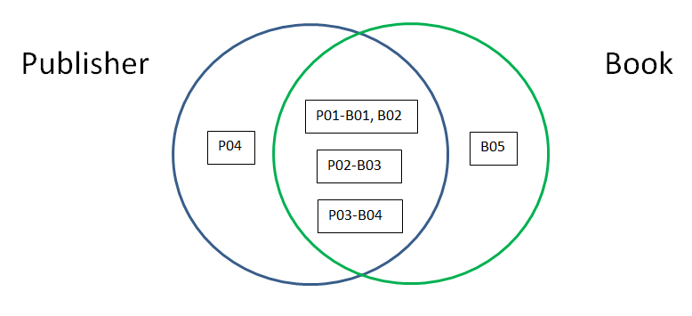
The full lines of code should be:
/*
create database Lab_8

Create table Publisher(
Publisher_ID nvarchar(50) Not Null Primary Key,
Name nvarchar(50),
Address nvarchar(50));

Create table Book(
Book_ID nvarchar(50) Not Null Primary Key,
Name nvarchar(50),
Author nvarchar(50),
Price int,
Published_Date date,
Publisher_ID nvarchar(50) Foreign Key References Publisher(Publisher_ID));

Insert into Publisher values
('P01','Pearson','Bukit Jalil'),
('P02','Deitel','Puchong'),
('P03','Rainbow','Subang');

Insert into Book values
('B01','Maths','J.Wenton','50','10 Jan 2016','P01'),
('B02','Science','S.Hanson','100','12 Feb 2016','P01'),
('B03','English','K.Vince','89','9 March 2016','P02'),
('B04','Biology','K.Vince','150','24 April 2016','P02');

INSERT INTO Publisher (Publisher_ID, Name, Address)
VALUES ('P04', 'MacHill', 'Kuala Lumpur');

INSERT INTO Book (Book_ID, Name, Author, Price)
VALUES ('B05', 'Computing', 'J.Denzin', '180');

Select *
From Book
INNER JOIN Publisher
ON Book.Publisher_ID = Publisher.Publisher_ID;

SELECT *
FROM Publisher
LEFT JOIN Book
ON Publisher.Publisher_ID = Book.Publisher_ID
Order By Publisher.Name ASC;

SELECT *
FROM Publisher
RIGHT JOIN Book
ON Publisher.Publisher_ID = Book.Publisher_ID
Order By Book.Name ASC;

SELECT *
FROM Publisher
FULL OUTER JOIN Book
ON Publisher.Publisher_ID = Book.Publisher_ID;

SELECT Publisher_ID, Name
FROM Publisher
UNION
SELECT Book_ID, Name
FROM Book;

SELECT *
FROM Publisher
FULL OUTER JOIN Book
ON Publisher.Publisher_ID = Book.Publisher_ID
WHERE Publisher.Name = 'Deitel';

SELECT *
FROM Publisher
FULL OUTER JOIN Book
ON Publisher.Publisher_ID = Book.Publisher_ID
WHERE Publisher.Name = 'Pearson' and Book.Author = 'S.Hanson';

SELECT *
FROM Publisher
FULL OUTER JOIN Book
ON Publisher.Publisher_ID = Book.Publisher_ID
WHERE Publisher.Name = 'Pearson' and Book.Author = 'J.Wenton' and Price Between 30 And 70;

SELECT *
FROM Publisher
FULL OUTER JOIN Book
ON Publisher.Publisher_ID = Book.Publisher_ID
WHERE Publisher.Address = 'Bukit Jalil';
*/

